Presto (Trino):

Let's start discussing what Presto actually is. Looking at the documentation you can see the short description. Presto is an open source distributed SQL query engine for running interactive analytic against data sources of all sizes, ranging from gigabytes to petabytes. So, Presto represents a cluster of one or more hardware instances where the software is deployed. Having this architecture allows Presto to horizontally scale its cluster infinitely because you can add more and more machines to the cluster based on your needs. And from client point of view, one user need to send a simple query in an ANSI SQL format to start interacting with the Presto cluster. It's a simple as that. Then the Presto cluster analyse the query and connects to the specific data source required by it. But now I guess you're wondering which are the natively supported data sources? Well, Presto provides integration with so many external resources. For example, databases like PostgreSQL and MySQL, Elasticsearch, Hive, Cassandra, Oracle and Redshift, There is also support for even stores like Kafka or even open for processing files placed storages like HDFS, S3 in Amazon and many more. But that's not all. Here actually comes Presto's power.

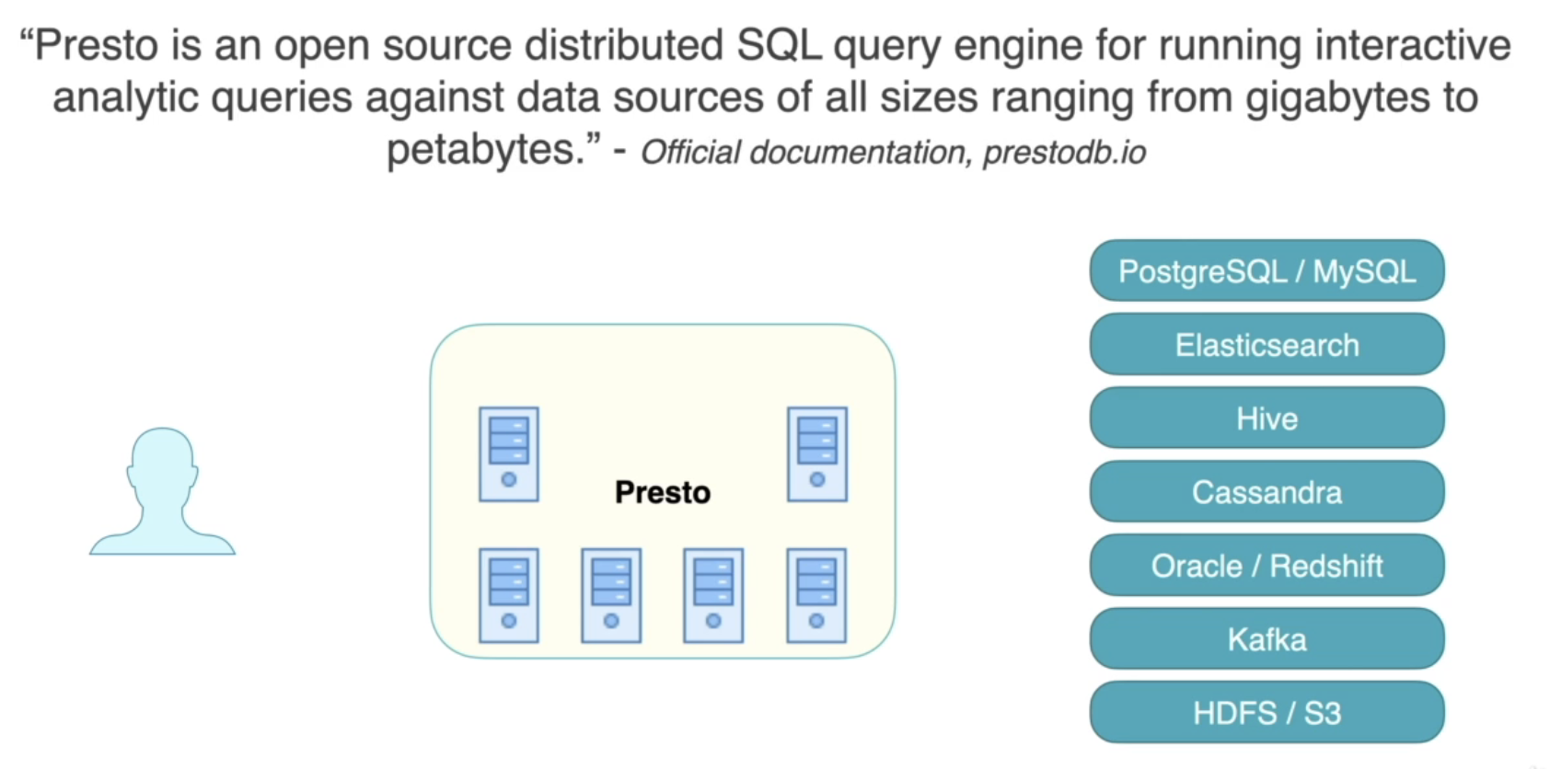

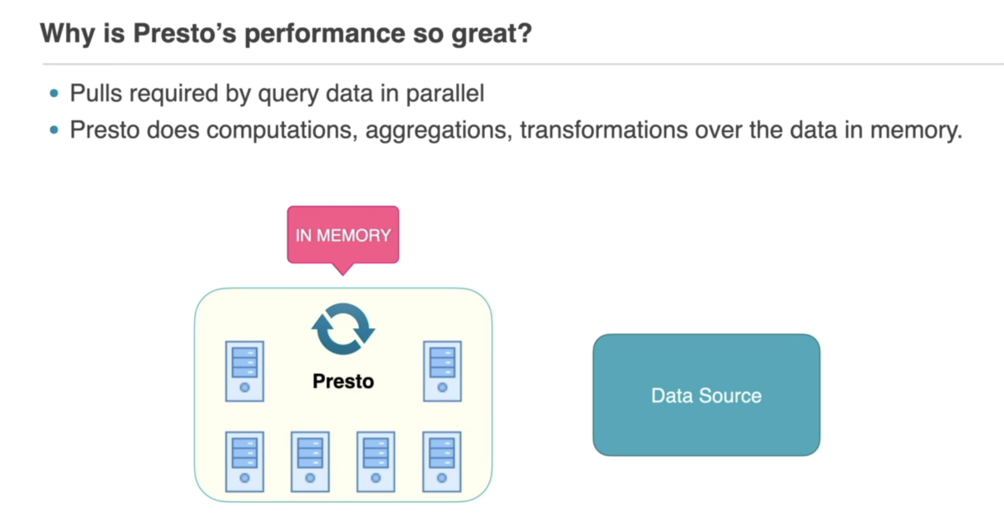

When Presto starts executing a query, it pulls the data which needs to be analysed in parallel and this leads to optimised query performance. And when all of the data is received by the server, Presto's machines start doing computations, aggregations and transformations over this data in memory. When the final output of the query is produced, it is returned as a response to the end user. And doing all these actions in memory is the reason why Presto's query performance is so great. With architecture like that Presto provides the amazing ability to execute interactive analytic queries with speed of commercial data warehouse while scaling to the size of petabytes of data.

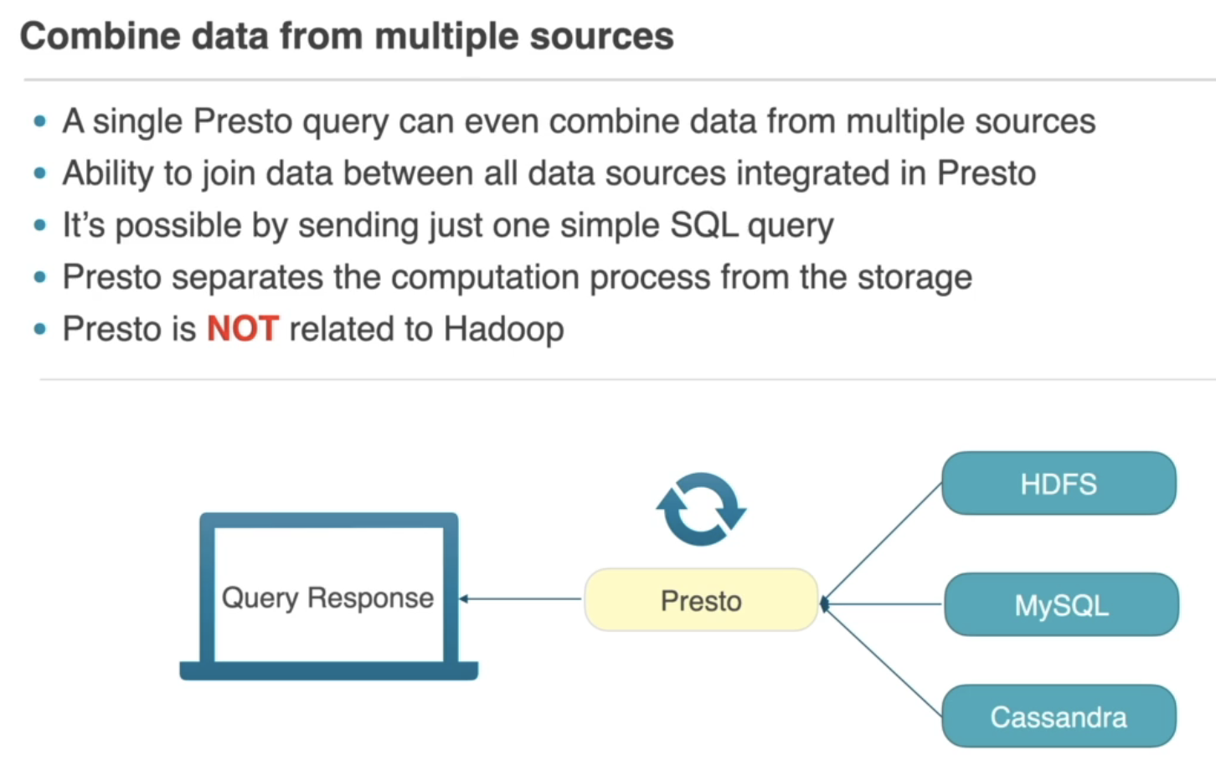

But even if you think that's not enough, let's see one more amazing Presto feature. A single Presto query can even combine data from multiple data sources. Just think about that! You can execute a join statement where part of the data is located in HDFS, another one in MySQL and the final part is in Cassandra. And you can join data between all data sources provided by Presto. But even if your data source still hasn't been integrated, you can a custom plugin for it, because Presto has been created with the idea to be extendable from anyone interested in adding more data sources. But now I guess your next question will be - how is that possible from client point of view? Well, for Presto's users, it's again just one simple SQL query where the correct source names must be defined and that's it. Presto is going to join the data from several data sources and return a single response to the end user. And when you know this, you can probably see again, that Presto separates the computation process from the storage. This way the computation process can be horizontally deployed in the cloud, easily depending on your scale. And another very important note about Presto is that Presto is not related to Hadoop. This means that you can run in whatever environment you prefer it's up to you. And by providing all these features, Presto becomes promising for any team and a company which want to analyse huge amounts of data, located in one or even more different type of storages.

Presto Usecases:

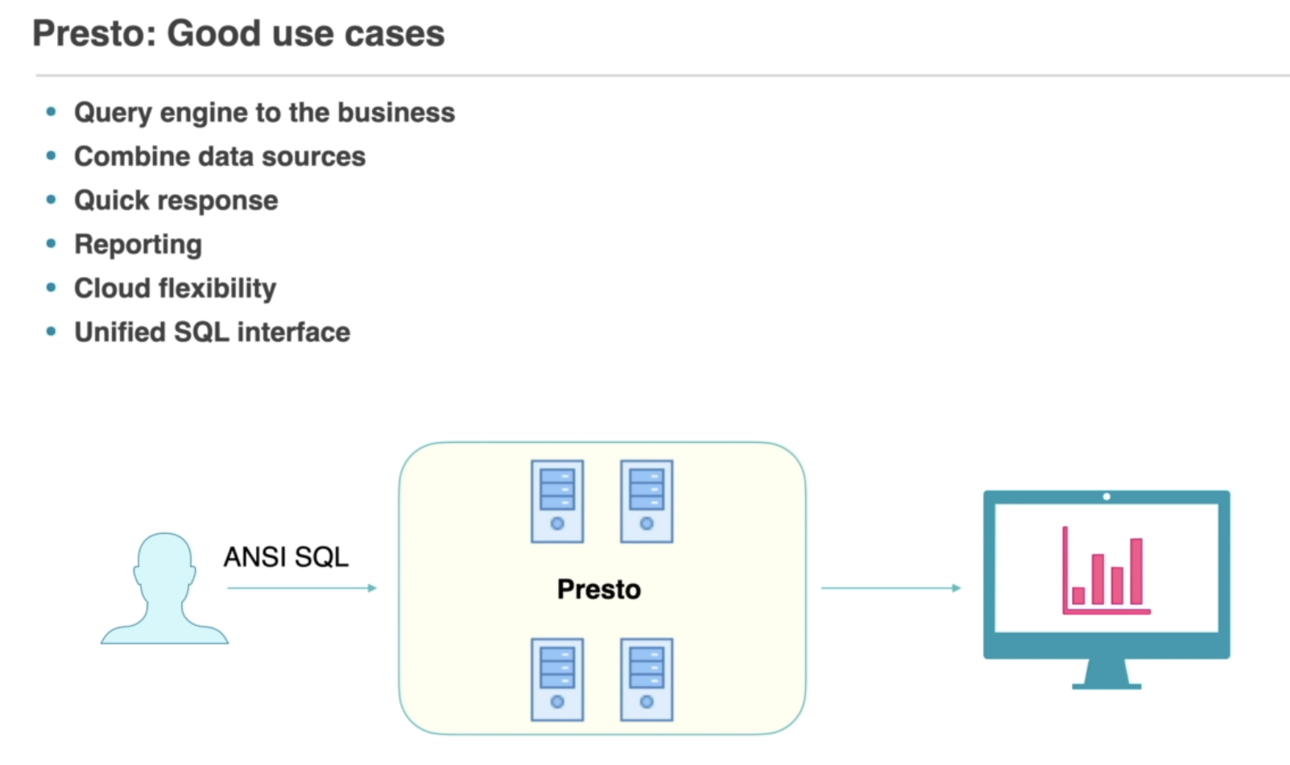

And the most important thing to understand is that Presto is created to execute queries over huge data storages, containing from many gigabytes, terabytes to even petabytes of data. So, knowing that, let's think for possible good Presto use cases. The most common one is SQL query engine for big data. These days the data becomes more and more important for every business. The data growth is enormous and all companies start collecting every possible data for their users. Unfortunately, it becomes more and more difficult to analyse this data, especially when the scale becomes bigger and bigger, and actually here comes Presto's SQL query engine. It allows companies to provide a query engine to the business, which can analyse from multi gigabytes to petabytes of data relatively fast to the data size. And not only that, Presto allows you to combine different data sources. Presto can join data from event stores like Kafka, with traditional relational databases like MySQL and finally join with parquet files from a data lake storage like S3 IN Amazon for example. And this feature optimises the costs for the business because the data is not required to be moved from all data storages into one specific place, hence you don't need to duplicate the same data in multiple storages. Moreover, the business will receive the final response of the analytical query much faster for the same reasons, you don't need to wait the same data from all sources to arrive into one specific place. And this can have again huge positive impact on the business because business decisions can be taken in almost real time. And you can also use Presto for reporting purposes. Until recently, it was extremely hard and expensive to build services for reporting. But with the evolution of the cloud services provided by Amazon, Google Cloud, Azure and many more, you can easily spin up a cluster with the right size for your needs and query data on demand in a few minutes. This way you can allow different businesses to query data from multiple data sources in no time at all. And when you don't need the cluster anymore, you can stop it with just one click or you can use an autoscaling functionality to automatically resize depending on your workload. And of course using this approach, it's not necessary to pay in advance for hardware, but you will only pay for the reports you are interested in. And that's not even all. Having an unified syntax to access data from different data sources is another great benefit of Presto. That's what using ANSI SQL query language is a really important factor when choosing the technology, because business people don't have to learn any new complex language. They can use the SQL which they're already familiar and comfortable with. And now when you know what are Presto's strength's, let's review for what Presto is not a good solution.

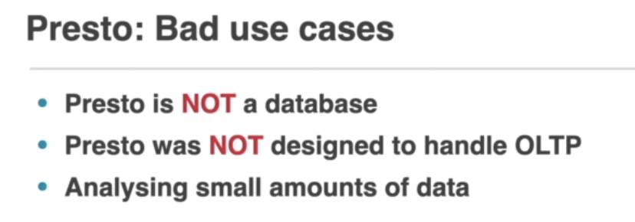

Presto Architecture:

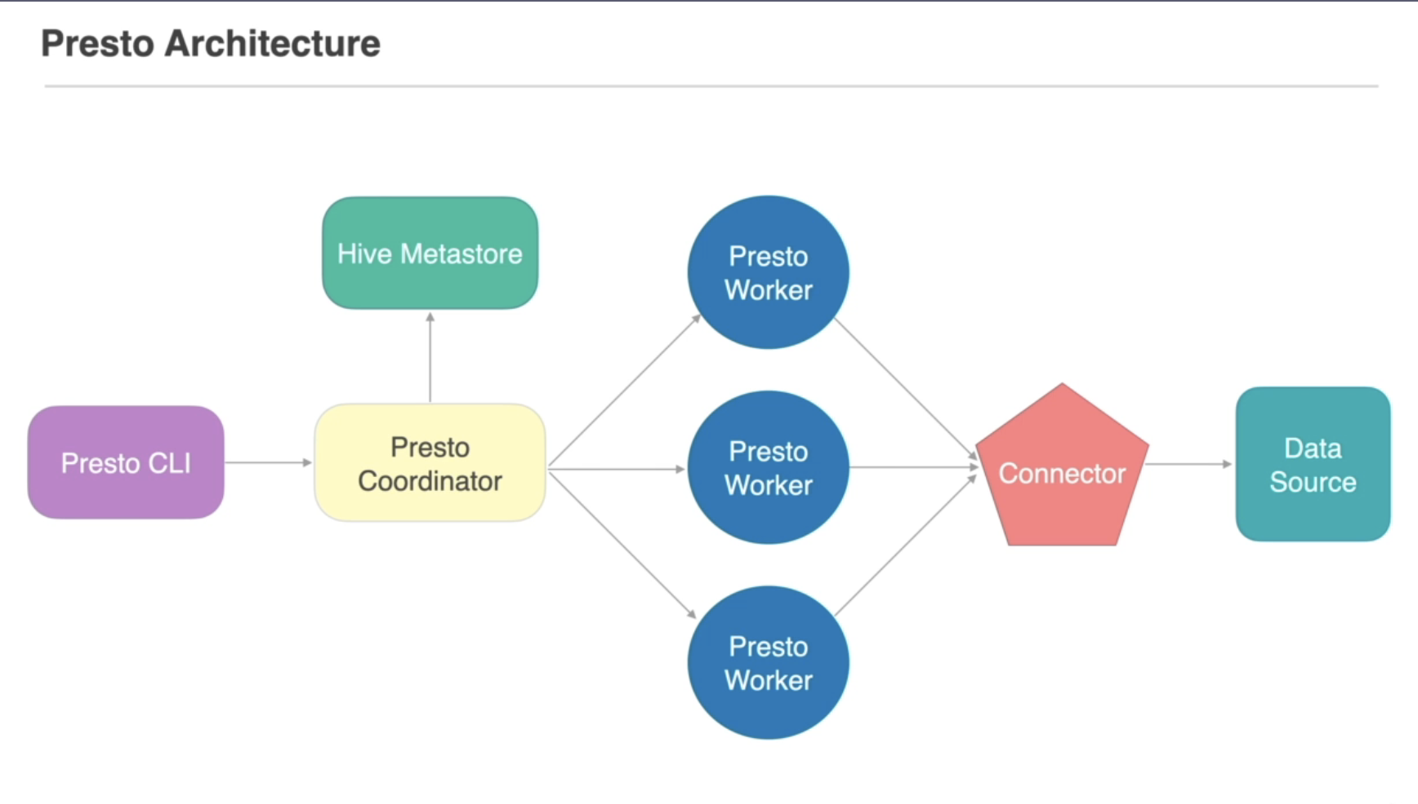

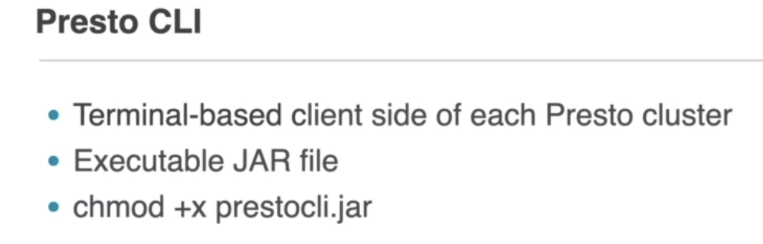

Presto Co-ordinator:

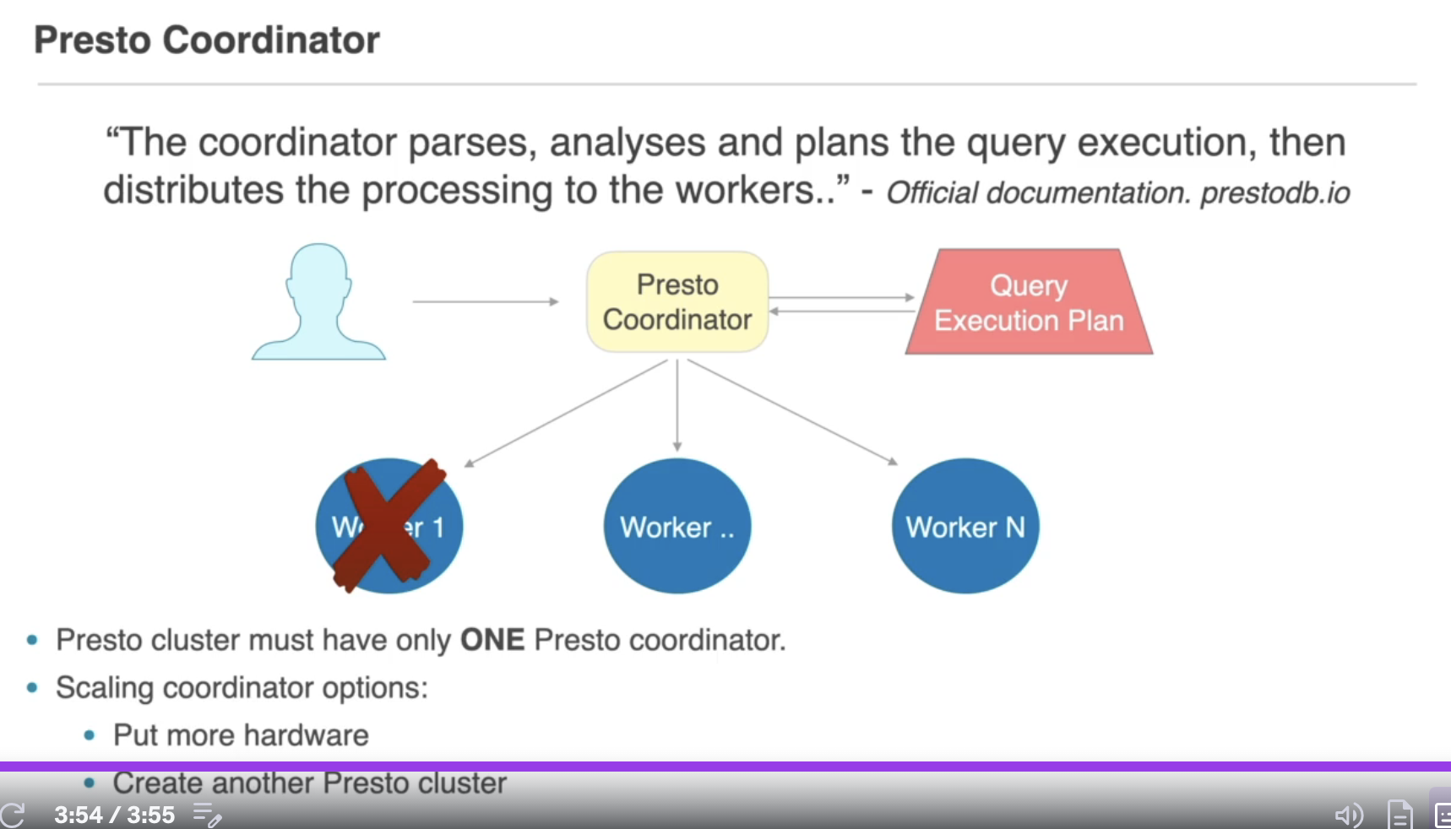

Well, when you send a query to the coordinator, the coordinator parses the query, analyses the query and based on this analysis, Presto creates a query execution plan. And this is where Presto becomes powerful. The query execution plan defines how a specific quarry will be executed across all machines in the cluster. And this is the reason why Presto processes queries so efficiently and effectively. So, let's imagine that the coordinator has already received a query execution plan. The next step is to distribute this plan to all machines across the cluster. And after that, the coordinator keeps track of the activity on each of these machines and coordinates the execution of the query. This communication is executed via a REST API over the HTTP protocol. And when something goes wrong with the execution of the plan, the coordinator knows how exactly to handle all these problems. In case when a worker fails, the coordinator can distribute a specific task from this worker to another one ,or can just return an error to the client. It's also important to remember that every Presto cluster must have only one Presto coordinator. It's not possible to have to a Presto cluster with more than one coordinator. And if you reach a case where you need to scale your coordinator instance, you have a couple of options available. The first one, and actually the easiest one, is to put more hardware on your coordinator's instance. And using this approach, you can scale vertically up to the limits of your machine. But of course, your machine can have insufficient limits and using the solution may not be enough to scale your coordinator instance according to your needs. So, there should be some other way. And the other option is to create another Presto cluster with another coordinator responsible for handling part of the client quarries. Doing it this way, you can distribute your queries between all of your Presto clusters. This is the only way to scale horizontally your clusters. And actually, this is how all big technology companies do it these days. All of them have hundreds of Presto clusters which process and analyse all of their analytical queries at scale. But have in mind that to even start thinking for more than one Presto cluster you should have really huge data storages where you need to run many heavy queries. Until then, you can continue scaling your Presto coordinator only vertically.

Worker:

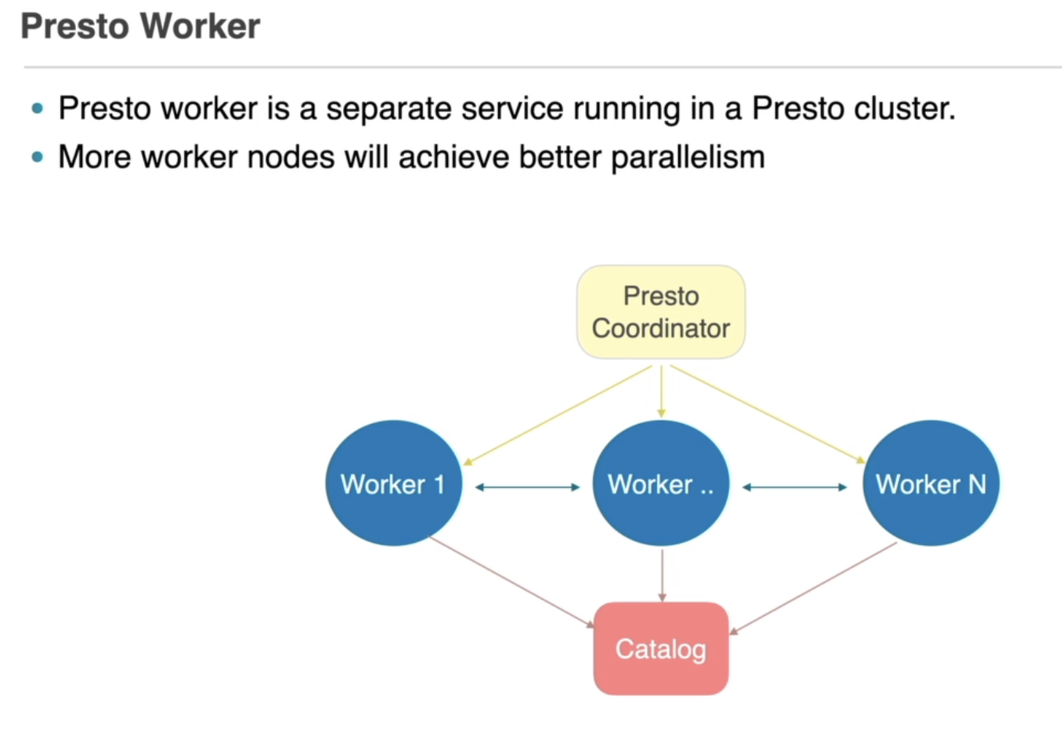 So what is the coordinator? The coordinator accepts a query, analyses it and prepares a query execution plan, which is then distributed to the machines in the Presto cluster. And these machines are named Presto workers. So, what is actually a Presto worker? Well, a Presto worker is a separate service running in the Presto cluster, but unlike the coordinator, you can have more than one worker. And not only that, you must have many workers in the cluster to which the coordinator can distribute the tasks. This way you can achieve better parallelism and better performance for your queries. But what is actually the worker doing? Well, every worker is responsible for two main things. The first one is to execute different tasks, part of the execution plan sent from the coordinator, and it is also good to mention that one worker can execute more than one task for a specific query and it can even execute them in parallel. And the second one is to process data from the appropriate catalogs. And as I already mentioned, the catalogs are a different kind of storage instances, which I'm going to discuss later in the course. And it's also important to understand that the worker nodes also exchange intermediate data within each other. Without the ability to communicate with each other, executing a specific task and producing the final result will not be possible. And when all workers have the final result, they don't produce it anywhere. The coordinator is responsible for fetching the results from the workers and returning the final result to the client. And another useful concept, which is good for you to know, is how the worker communicates with the coordinator.

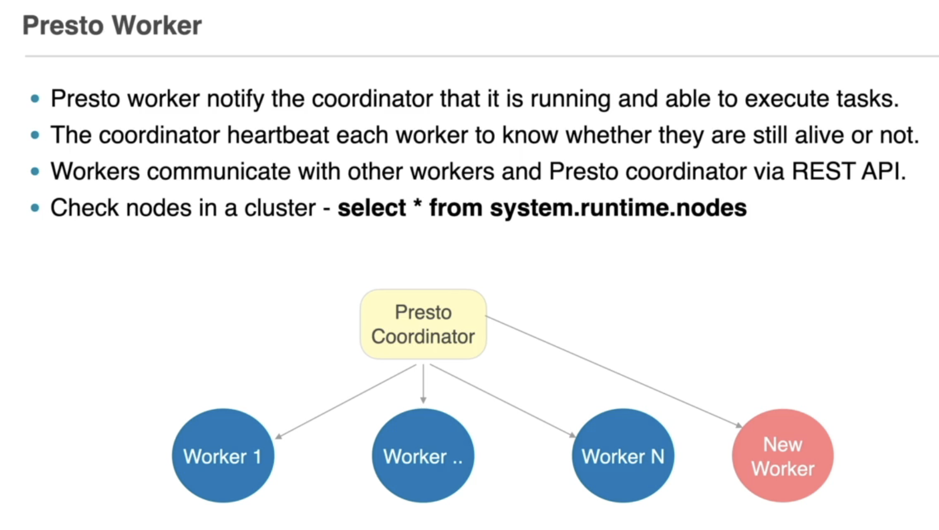

When a Presto worker node starts running, it connects to the coordinator machine. The coordinator runs a discovery service on its machine, different than the coordinator service itself. And the Presto worker will notify this specific service that it is running and able to execute tasks. And this way the coordinator will know for the existence of all workers in the cluster. OK, but most probably your next question will be what if some of the worker nodes go down? Well, to prevent sending tasks to failed worker notes, the coordinator heartbeats each of them to validate whether they are still alive or not. This way, it will send the tasks only to the active worker nodes in the cluster and the whole communication between the workers and the coordinator happens via a REST API. And if you're also wondering, is it possible to check how many workers exit in a Presto cluster? That's definitely possible. You can easily check it by running a simple SQL query through the Presto CLI - select * system from systme.runtime.nodes; and this query will return all nodes available in the cluster at the moment - the coordinator and all workers.

Connector:

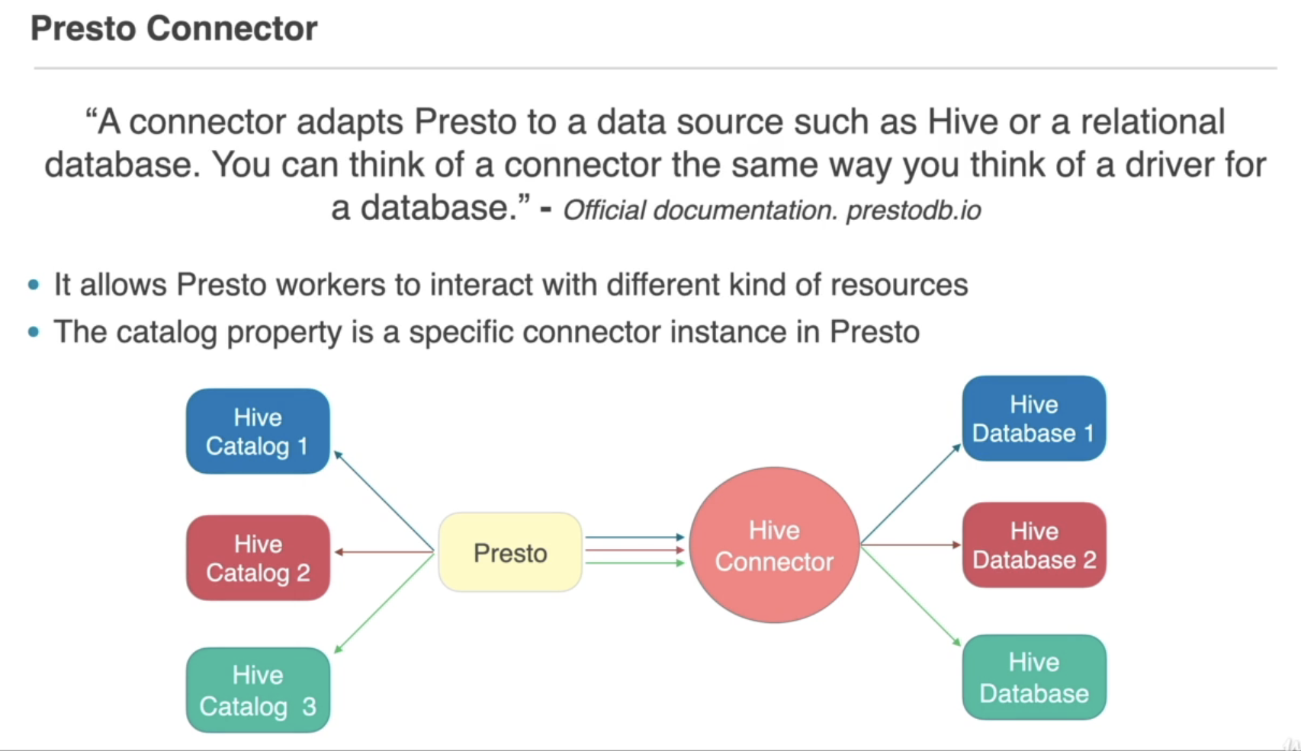

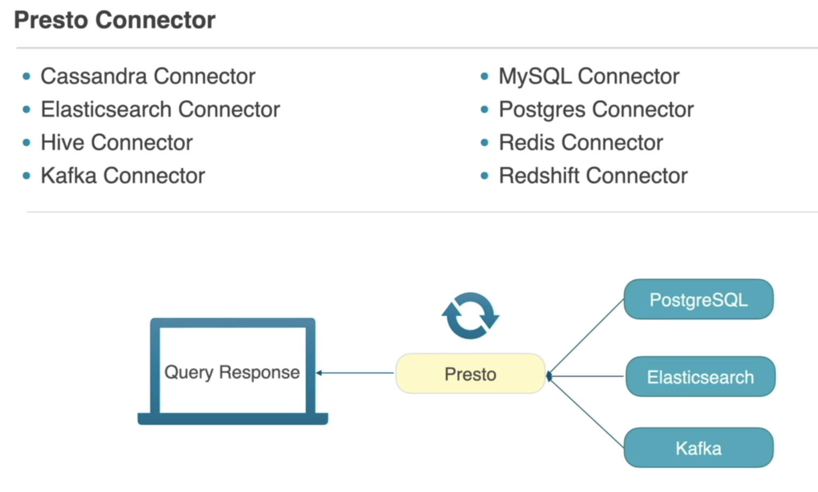

How are the worker nodes processing these queries? Well, here comes the next complement - the connector. Let's see what is the connector, why do you need it and what are the different type of connectors that Presto provides? First, looking at the official Presto documentation, you can see that a connector adapts Presto to a data source such as Hive or a relational database. You can think of a connector the same way you think of a driver for a database. So basically, the connector allows Presto workers to interact with different kinds of resources using a standard API. And I have already mentioned connector multiple times. The first time was during the Presto CLI lecture where I defined the catalog property. But now you're probably wondering - how is the catalog property related to the connector? And the answer is a really simple one. The catalog property is a specific connector instance in Presto. So let's explain it with a simple example. You may have several databases which you want to access from your Presto cluster. And to do that, you must configure a separate catalog configuration for each of the Hive databases where a catalog contains information how Presto to connect to a specific database. Basically security information and credentials like host, port, username, password, etc. Then the Presto workers will read the catalog configurations and initialise an instance of the Hive connector with a particular catalog configuration for all of the Hive databases. If the configuration is correct and Presto manages to connect to a specific database, you will be able to query data from it. But probably your next question will be - how many connectors come out of the box for me and which are they? And the answer is a lot. One of the amazing things about Presto is that Presto comes with a huge amount of built-In connectors for different kind of data sources. Some of the most important connectors are for Cassandra Elasticsearch, Hive, Kafka, MySQL, PostgreSQL Redis, Redshift and many more. Presto's architecture fully abstracts the data sources to which you want to connect. This way Presto creates a separation between the computation and the storage, hence, you can easily implement a custom connector for every software product by just implementing the required interface. And the only requirements to be able to model data into relational concepts such as tables, columns and rows. And as I have already discussed earlier in the course, Presto provides even more powerful functionality related to the connectors and the catalogs. You may want to join data from different data storages. And for the purpose of the task, you need to move the whole data from all data storages into one specific place. But that's not the case with Presto. Presto can run queries on top of different kinds of data sources, join them and produce a final output. Yes, you heard it right. You can join data for example from PostgreSQL, with data from parquet files in S3 and finally join with data from a Kafka stream. Once you have a catalog file for each data source, you can join data from any of these catalogs in a single SQL query. It is that simple for the consumers of the Presto cluster. That's really an amazing feature and extremely powerful for any kind of needs.

Metastore

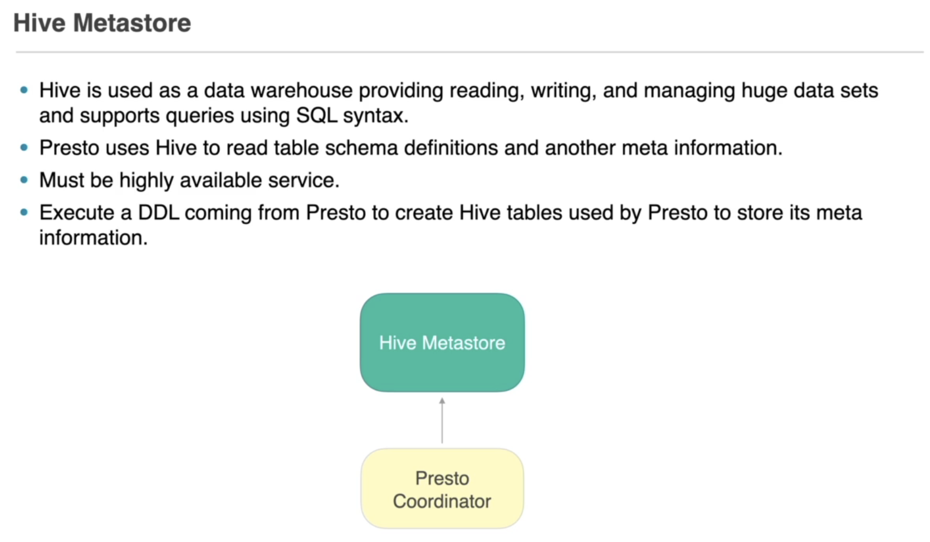

Trino execution Plan:

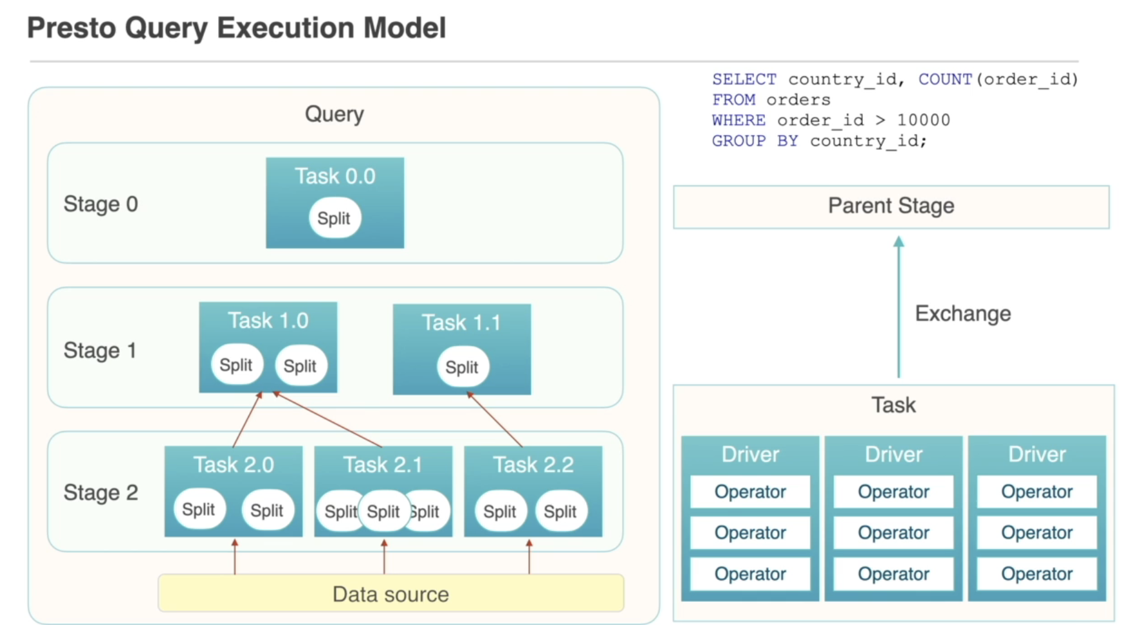

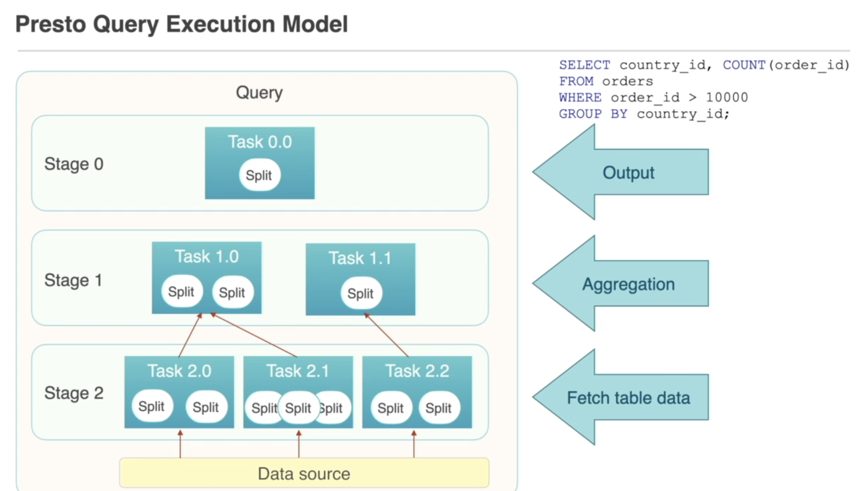

So let's summarise what we have discussed for now. A Query object is built for each new Statement received by the coordinator. And based on the query execution plan for a Statement, a hierarchy of Stage object is created. Each of these Stages contains multiple Tasks which are executed on the workers. But what is the actual job that is executed in these Tasks? Each of these Tasks need to execute multiple Splits. Splits are basically sections of a larger data set and are responsible for handling input and output operations between Presto's internal components and between Presto and other external data sources. Basically, Splits are chunks of data which can be fetched in parallel for a better performance. And because Stages represent a list, if you are at the last element of the list, this Stage will use the Splits to get data from external data sources in parallel. But if you're at a previous stage, this Stage will use Splits to retrieve results from all tasks in the Stage below and start doing some other actions with the output from them. This whole process is executed by the coordinator and the coordinator will save information in the metadata database about which machines in the cluster are processing which specific Tasks and which Splits are processed by which specific Tasks. And to achieve better performance one Stage can have many Splits doing all these actions in parallel. And as you know this, let's move on to the next components - Driver and Operator. One Driver can contain several Operators, and an Operator basically consumes, transforms and produces data. Think about Operators like different actions which can be applied over a data set. For example - filter, count, group, etc. And we know that let's go back to the Driver. Each Presto Task may run several Drivers in parallel, and each of them include multiple Operators. Basically, a driver combines data from different Operators and produces a final output for a specific Task object. Then the final Task object output is passed from the Task to the upper Stage in the execution plan. And to be able to achieve this transfer between Stages, Presto uses another component named Exchange, which produces the final data into an output buffer, which can be consumed from other Tasks using an Exchange client. And all of the operations in the Driver are executed in memory, that's why these operations and Presto at all are so fast. And actually, that's it about the theory. Probably are a bit confused at the moment, because this was too much theory in a couple of minutes, that's why I'm going to explain it again with a real SQL query example. Let's say that the same SQL statement is passed to the Presto's coordinator. Then the coordinator needs to aggregate this data from billions rows located in some data storage, which can be MySQL, parquet files or any other resource available as a connector. Presto's coordinator then creates a Query object which will split the execution into three Stage objects - Stage 0, Stage 1 and Stage 2. Basically the same as the diagram at the moment. Obviously, Stage 2 is the lowest one and Task objects located in this Stage will the whole data set required by the Query in parallel by using multiple Split objects. That includes running multiple Drivers and Operators, which will filter the data to the fields needed by the Query? Or in other words, the Operators will skip old columns different than the country_id and order_id. When the Tasks are ready, they will provide a clean data required by the Query to the Tasks in Stage 1. Then Stage 1 is responsible for doing all transformations and aggregations over the clean data set provided by Stage 2. The Tasks in Stage 1 need to calculate the count part of the SQL Statement by again using Drivers and Operators. And when the final response is ready, the final data set will be returned to the root Stage and this will be the end of the Query. And actually, that's it. Hopefully now you have a better understanding about the Presto's query execution plan and it doesn't look so complicated anymore, right?

Datatypes

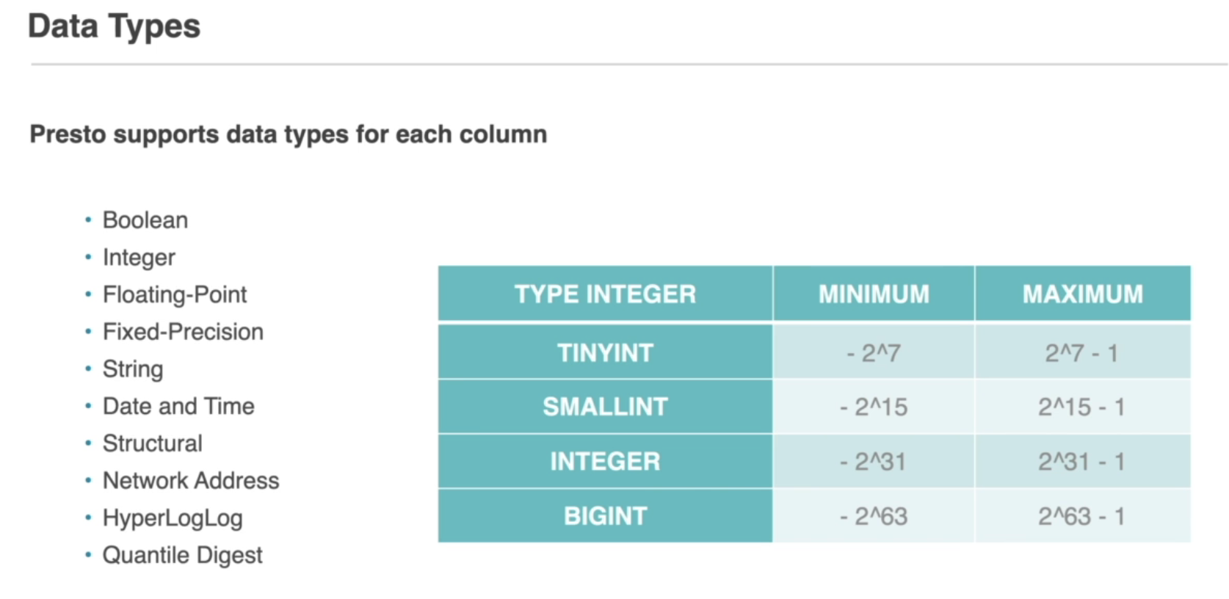

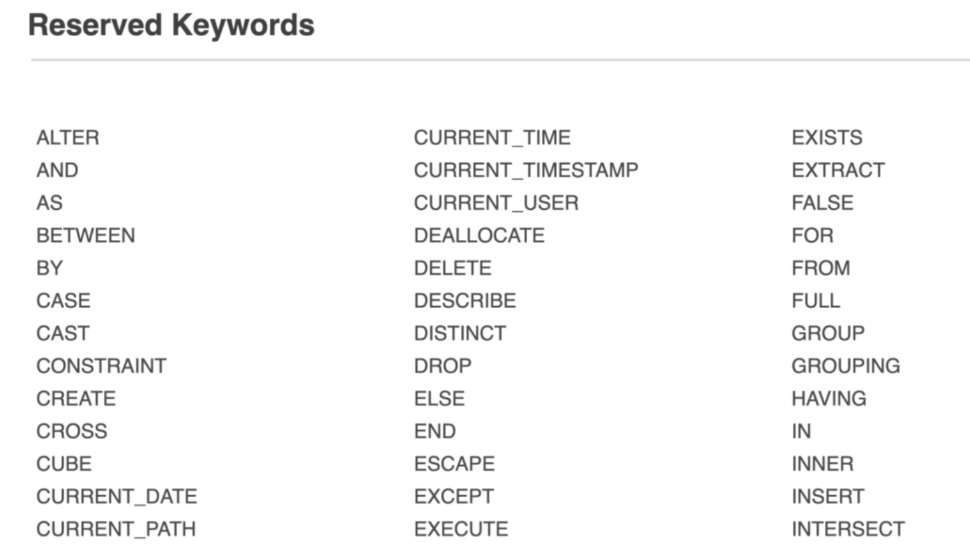

Datasources:

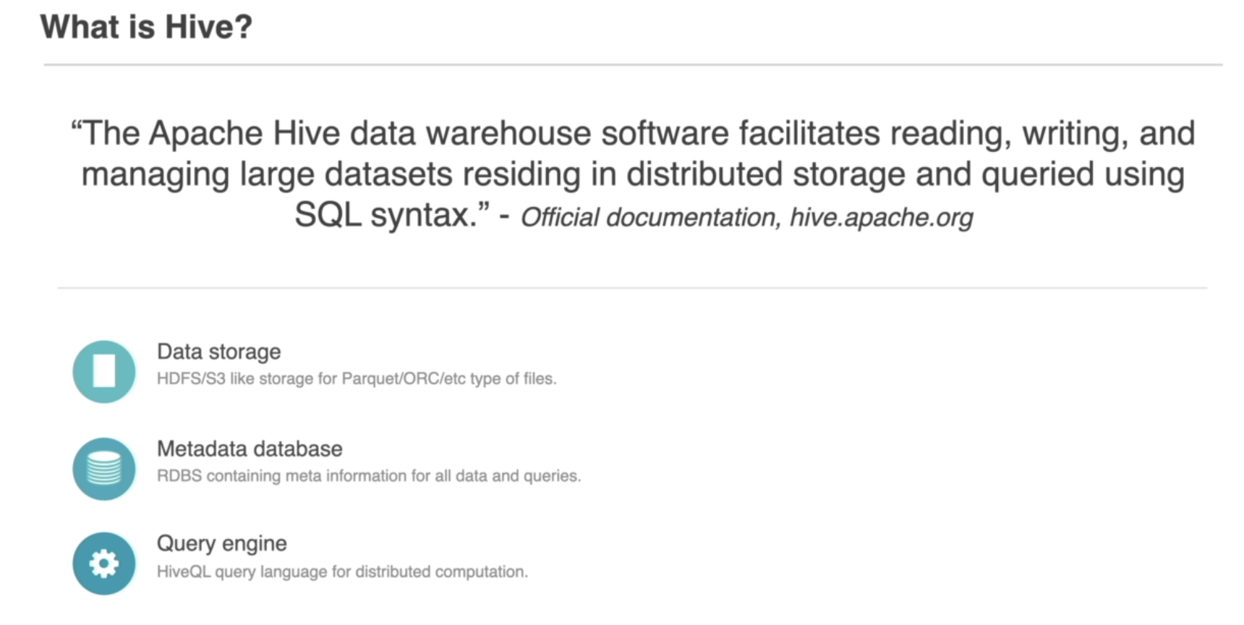

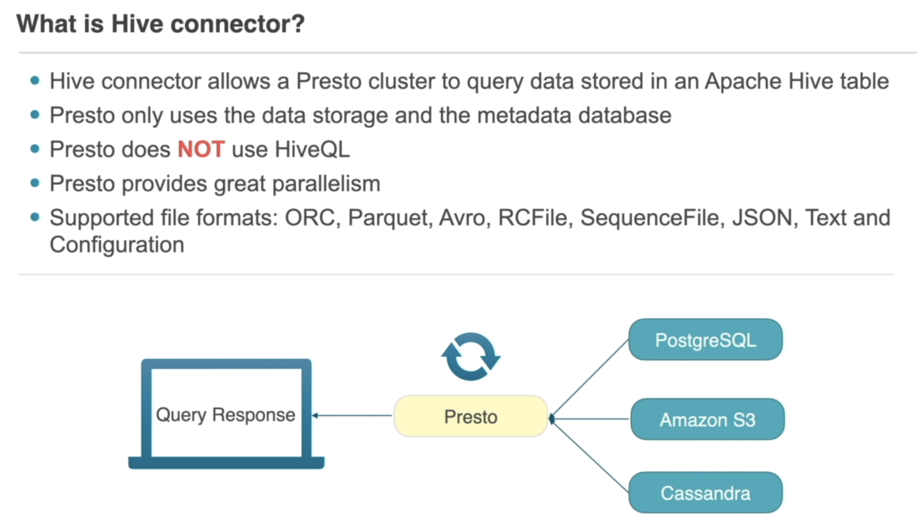

Postgres Connector:

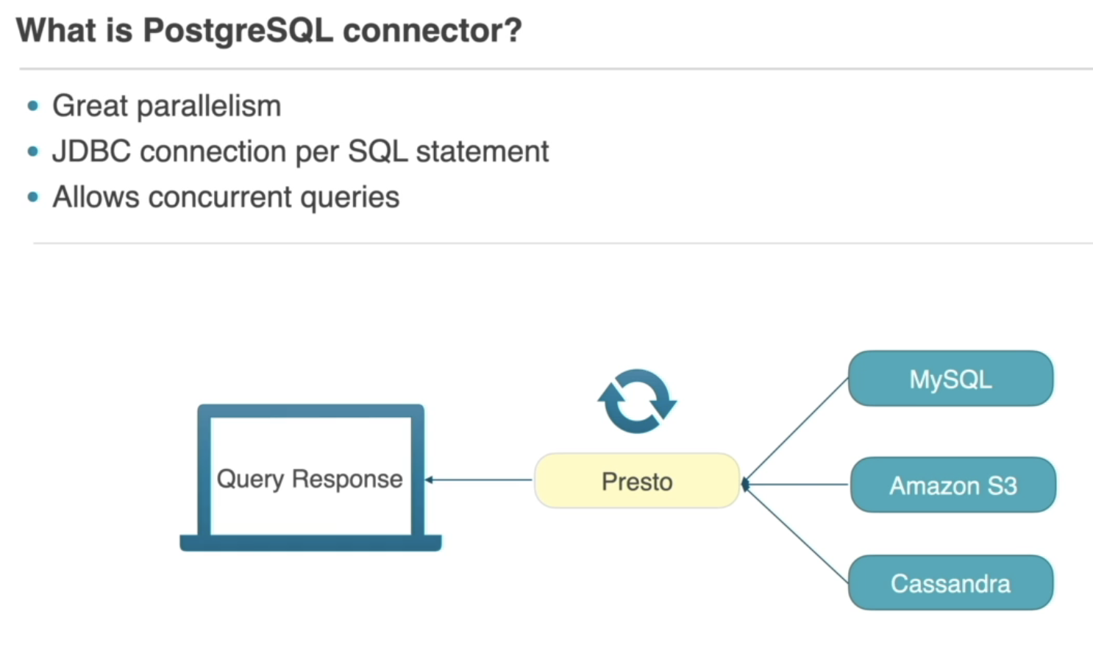

Configs:

